**Project Report**

**Nguyễn Hữu Hải Nam – HE150638 ( SE1505 )**

1. Introduce case of study:

- In the case of covid-19 nowadays, we should as much as possible, avoid crowds and limit from outdoors spaces. However, the demand on the consumption of people still increase day by day. As we can’t get out so online shopping, ecommerce is the solution for this demand. So I create a web online shopping based on the knowledge I got from PRJ301 at school. This is my summary about my project.

II. Database design:

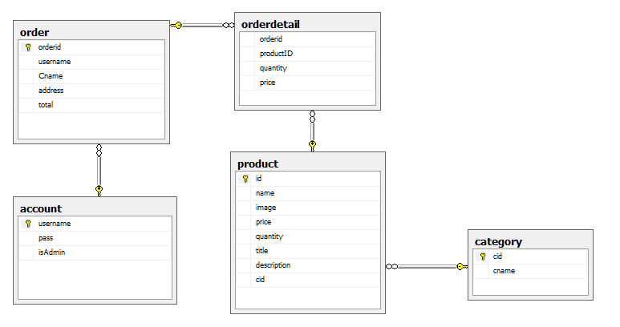

III. System design:

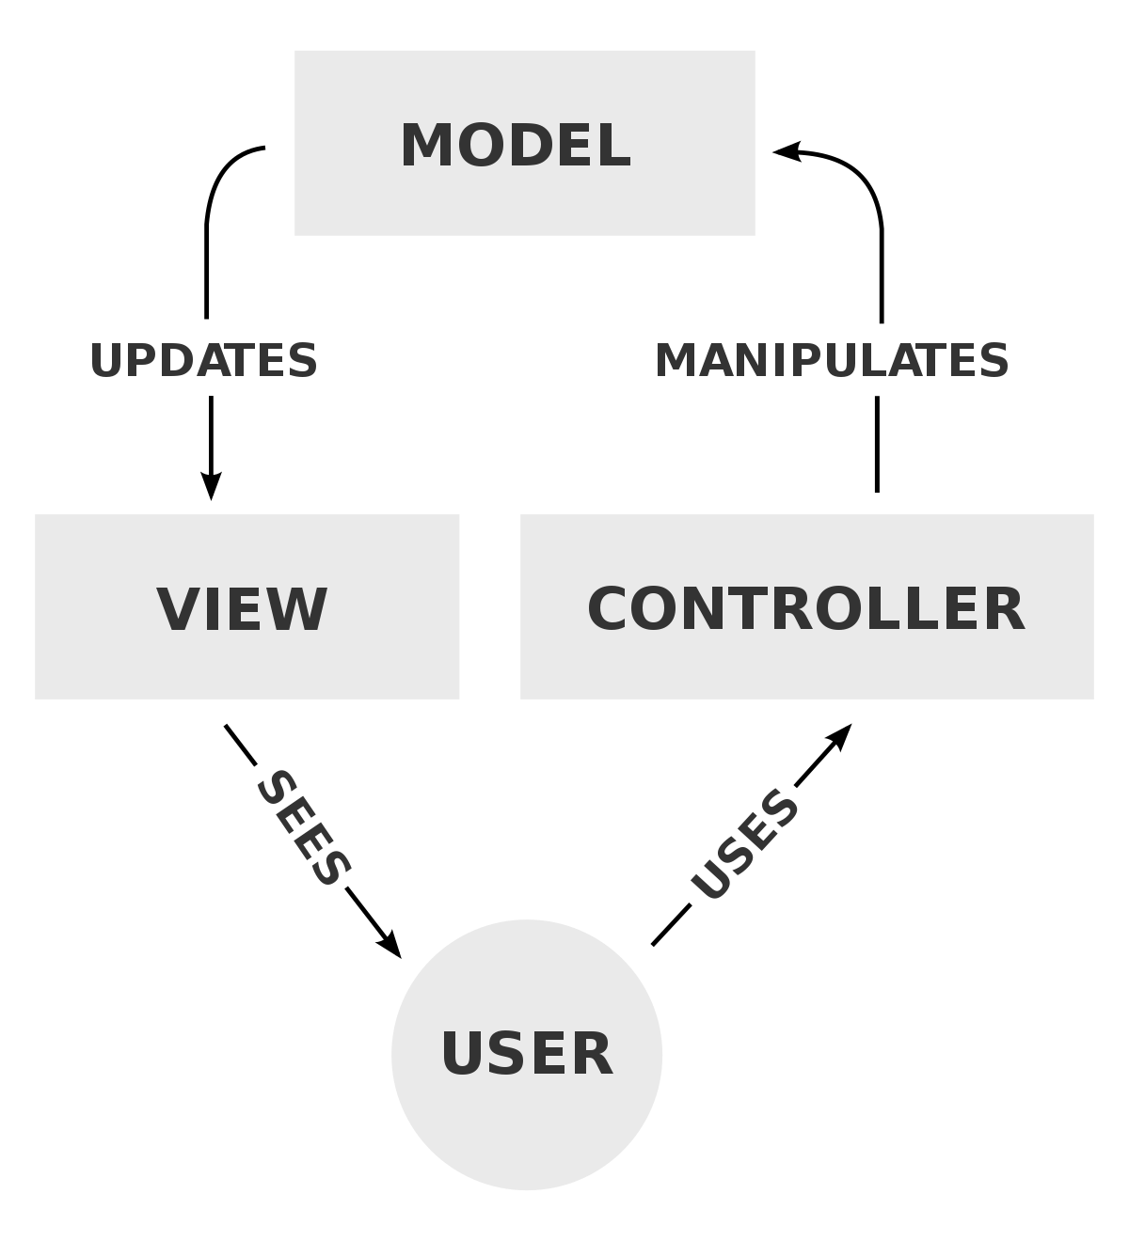- This project is designed using knowledge about JSP- Java Servlet and based on software design pattern MVC - stands for Model – Controller – View, commonly used for developing user interfaces that divide the related program logic into three interconnected elements. This is done to separate internal representations of information from the ways information is presented to and accepted from the user.

1. Model:

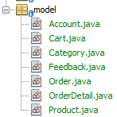All data-related logic that the user interacts with is represented by the Model component. In my project we have model like:

This might be the data that is being transferred from database or between the View and Controller components, or any other data that is linked to business logic.

2. Controller:

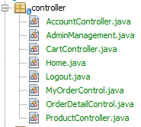Controllers act as an interface between Model and View components to process all the business logic, incoming requests and directional url, manipulate data using the Model component and interact with the Views to render the final output.

3. View:

View is that what the users, customers can see. It will be directional by controller after get request from users. In this project, I used JSP ( include HTML5, CSS and JavaScript) to build.

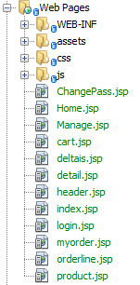

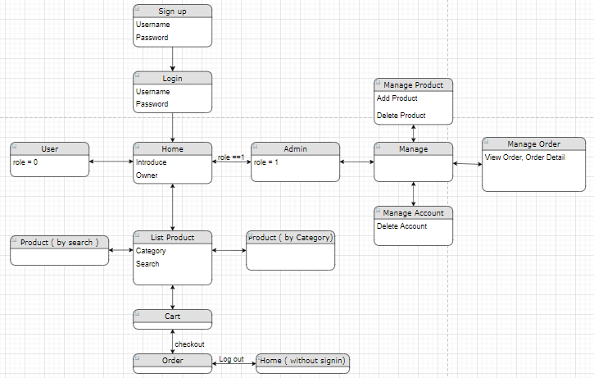

Overview

**IV. Screenshot:**

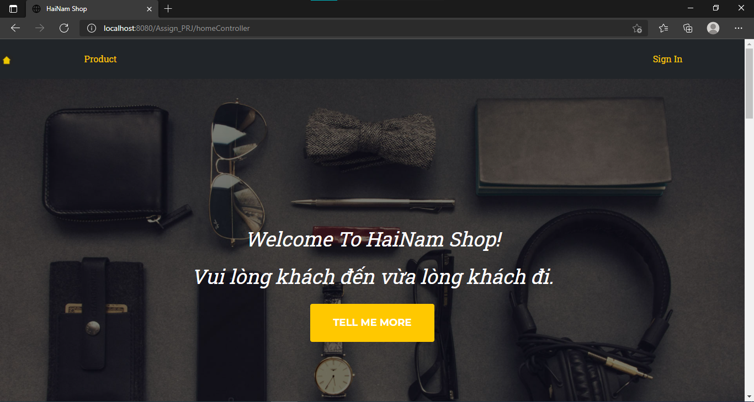

Home with out signin

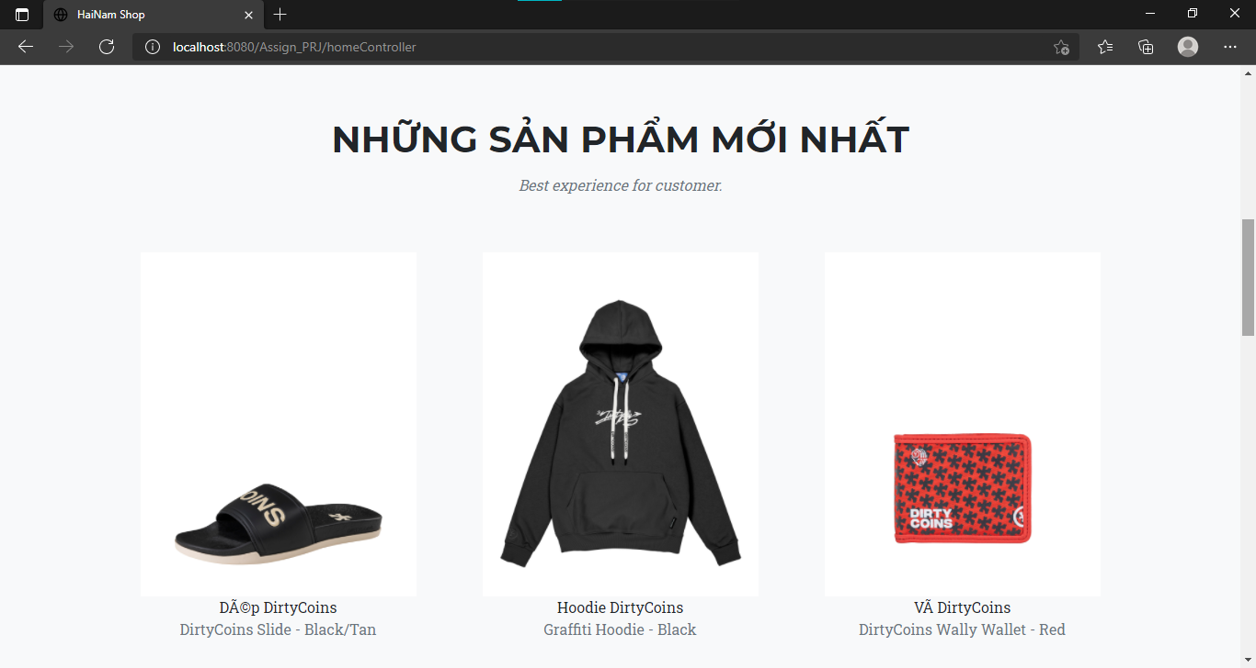

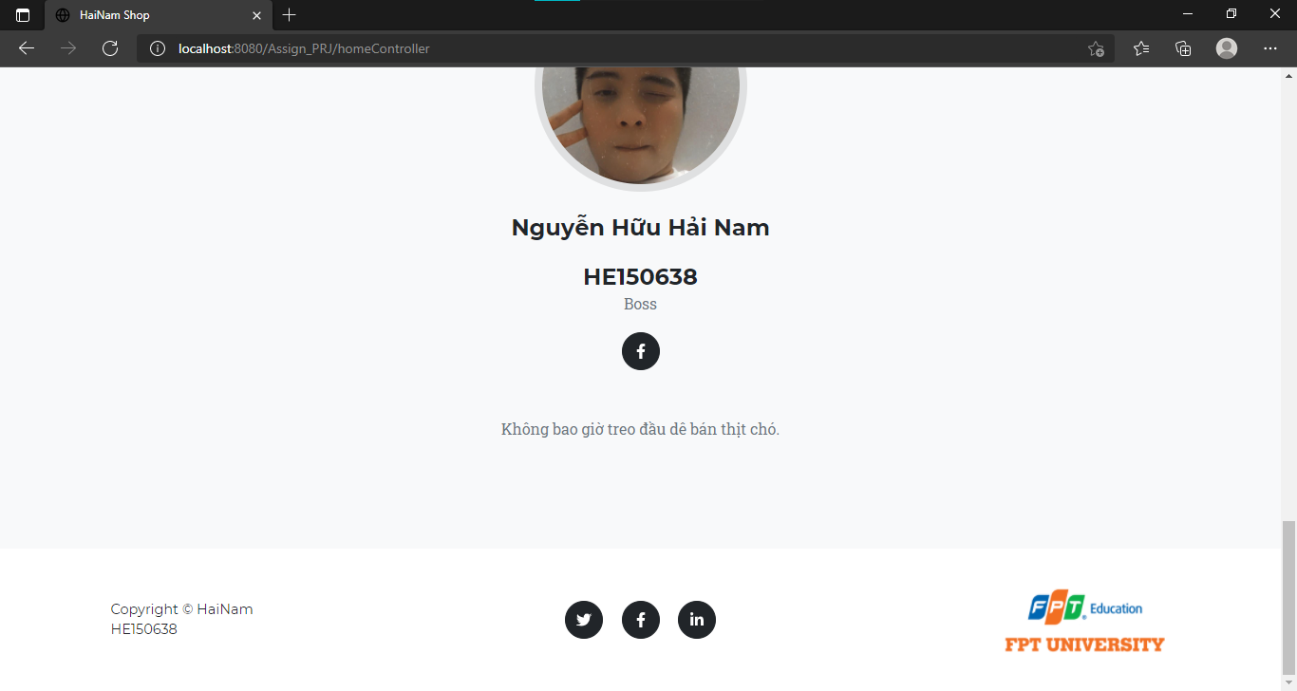

HomePage

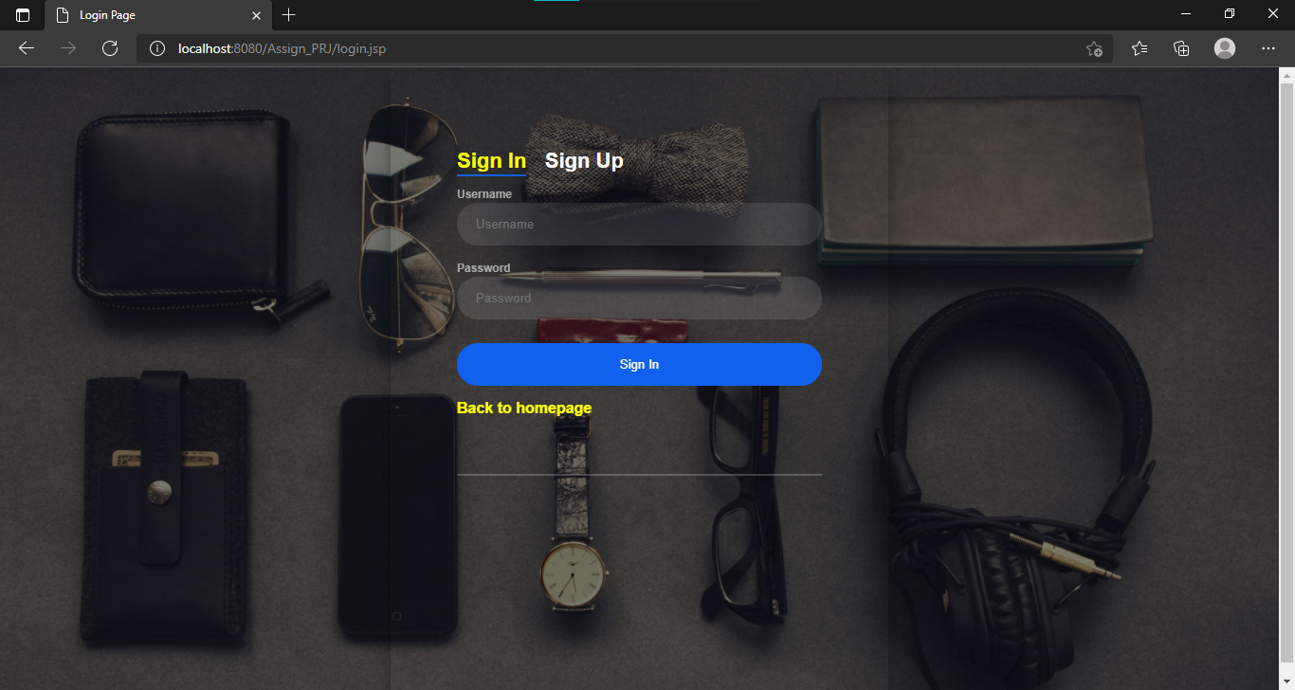

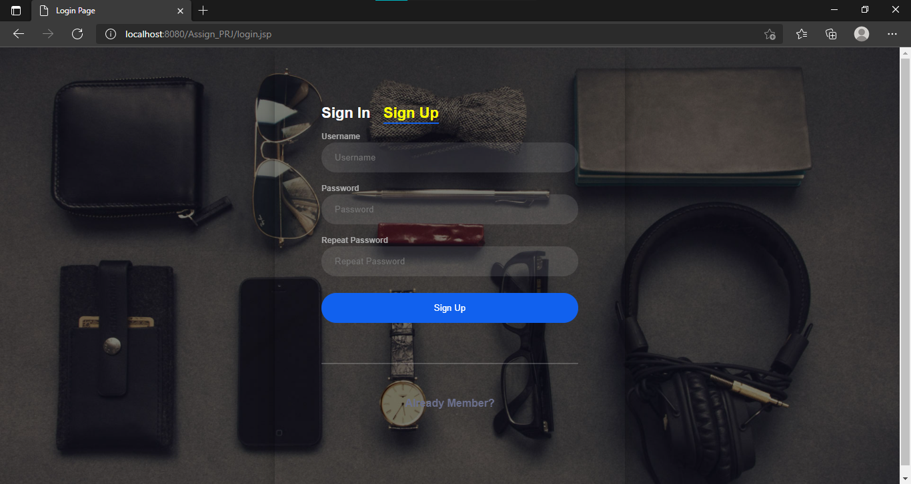

Sign in – Sign up

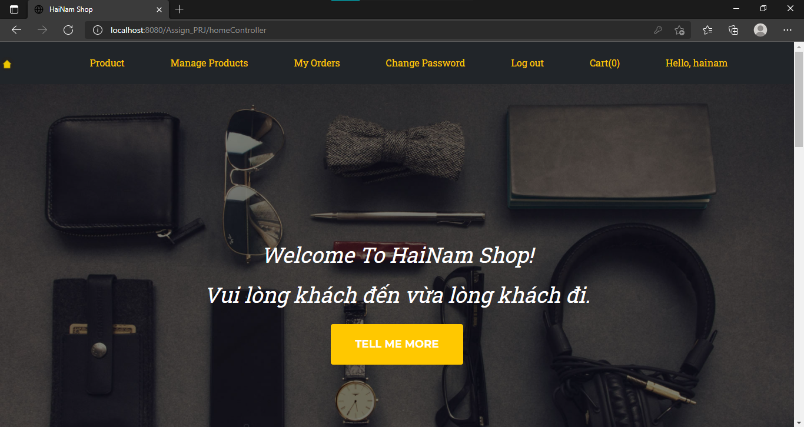

Home ( admin )

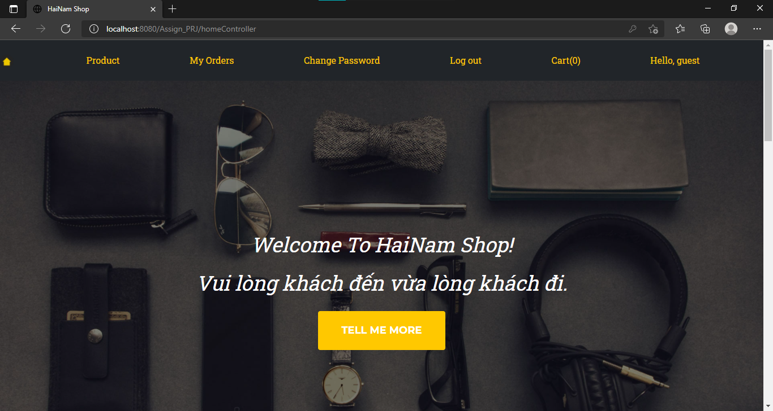

Home ( guest )

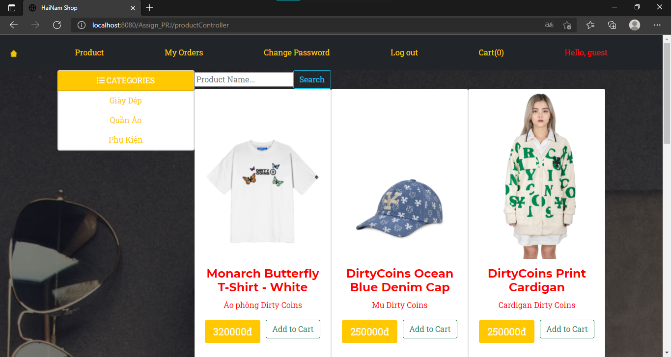

Product List ( include: category, search )

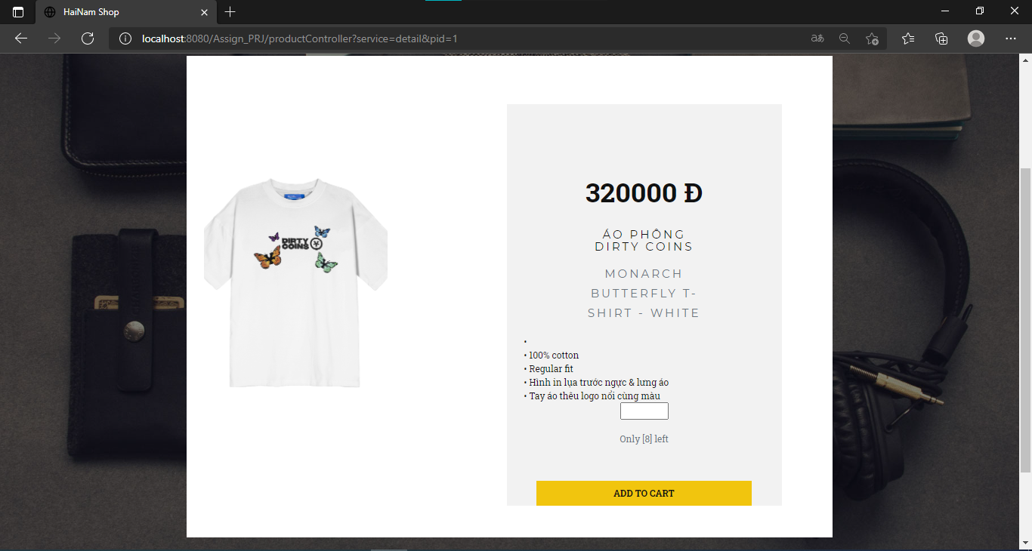

Detail Product

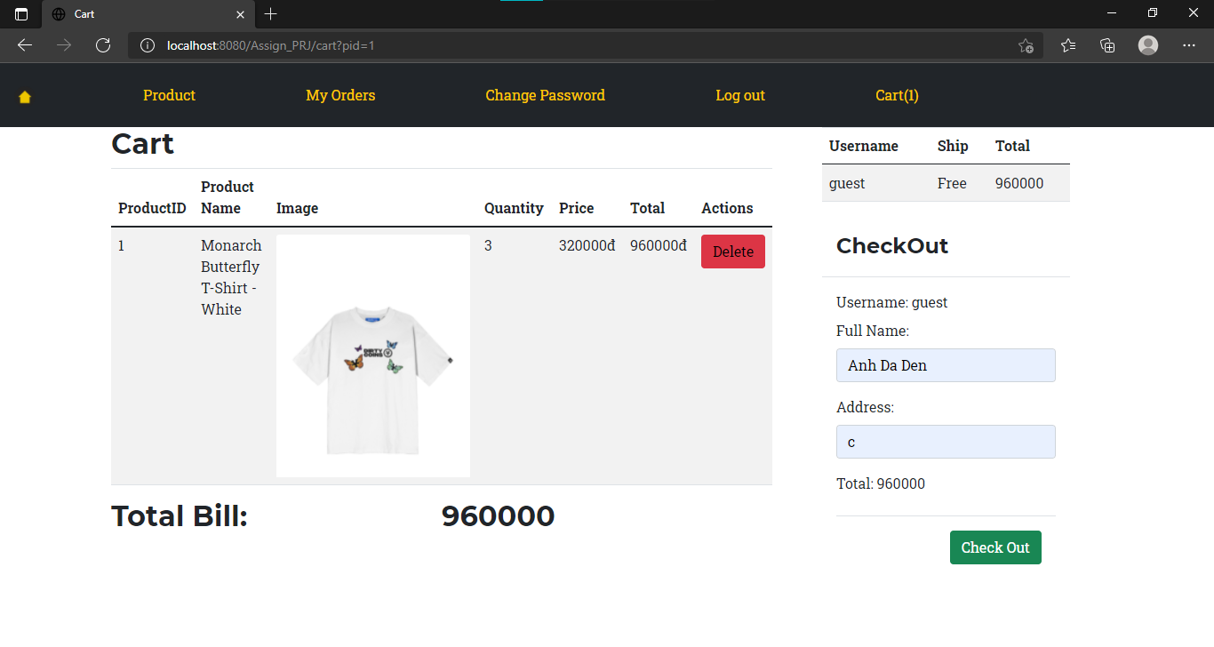

Cart ( 1 product )

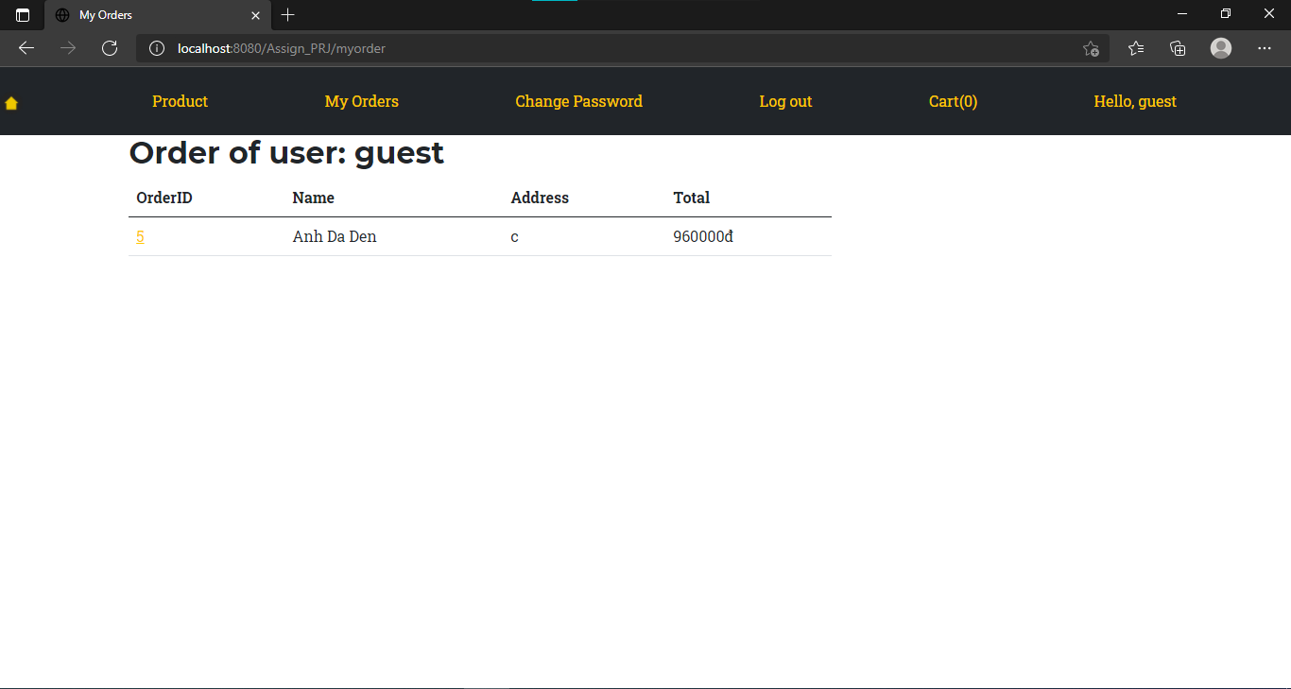

After checkout ( List Order by username)

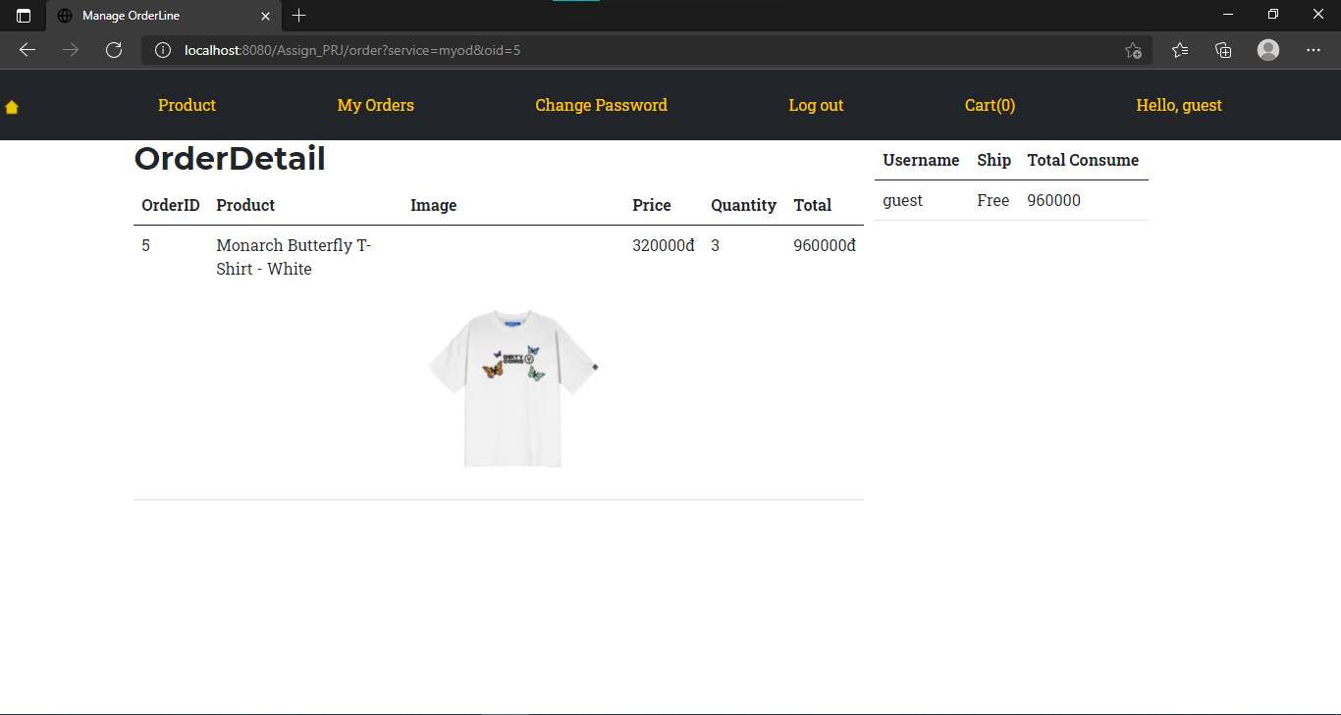

OrderDetail after click OrderID

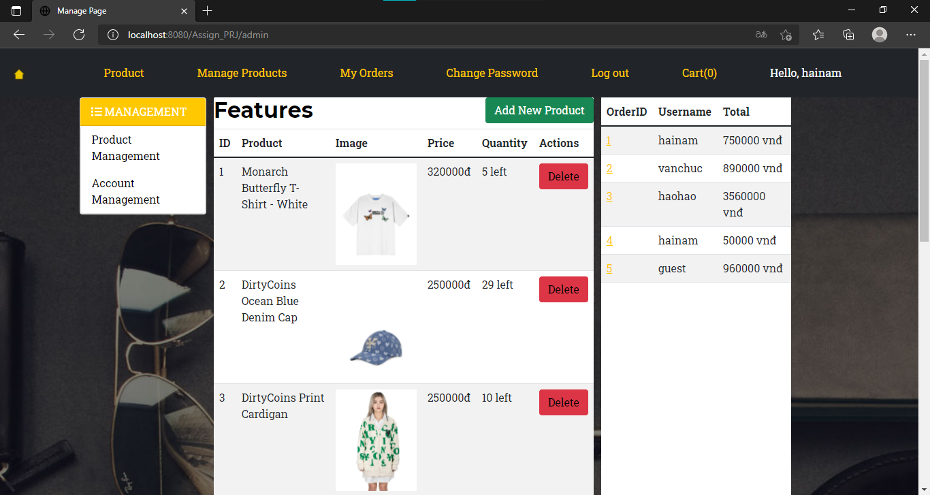

Manage Products, Accounts, Orders ( Admin only )

**V. Conclusion and Discussion:**

**A. Conclusion:**

1. Friendly interface, easy to use

2. Fully features, utilities

3.Admin management system ( product, account, order)

**B. Discussion:**

-This assignment is necessary because after finish this project, we can make your own website using your knowledge gain from study. Beside, we can find other mistakes that we only can discover if we make the project on your own: bugs, how to debug, find solutions. We can feel the proud of myself after finish something quite big (at the moment).

-Some reference sources used in project: w3school, stackoveflow, template front-end (nicepage).